Data Technician
Workbook
Week 6 Python

Name: Ana Maria Caceres Prada
Course Date: 16 March 2026

How to Share your notebook
- Select share
- Enter and add trainers’ email yusufs@justit.co.uk
- Make sure that you set General access to Anyone with the link.
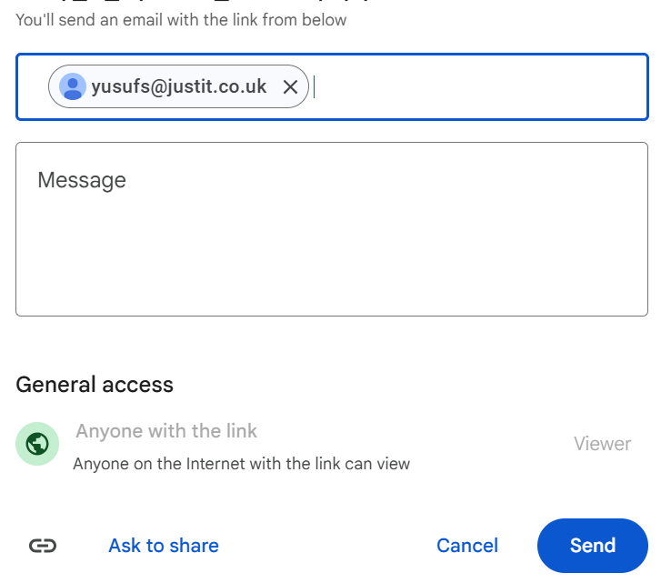
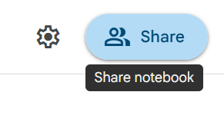
- Press send.

Day 1: Task 1
- Follow below link. https://colab.research.google.com/drive/1X2y7wcJ768lPnnq4HEOK2hpeefz3Bzl5?usp=sharing
- Save a copy of this notebook in your Drive and rename by adding your name to the end.
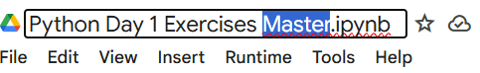

- Go through the notebook and complete the exercises at the end.
- Share your notebook with your trainer.

Day 2: Task 1
- Follow below link.
- https://colab.research.google.com/drive/1FMs6Dqg_tTSqn0wAuTa0aTX_vkYwkEJM?usp=sharing
- Save a copy of this notebook in your Drive and rename by adding your name to the end.
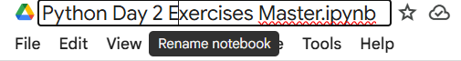

- Go through the notebook and complete the exercises at the end.
- Share your notebook with your trainer.

Day 2: Task 2

It is a common software development interview question to create the below with a certain programming language. Create the below using Python syntax, test it and past the completed syntax and output below.

FizzBuzz:

Go through the integers from 1 to 100.
If a number is divisible by 3, print "fizz."
If a number is divisible by 5, print "buzz."
If a number is both divisible by 3 and by 5, print "fizzbuzz."
Otherwise, print just the number.
Use loops and if statements.

Paste your completed work to the right | for i in range(1, 101):  if i % 3 == 0 and i % 5 == 0:  print("fizzbuzz")  elif i % 3 == 0:  print("fizz")  elif i % 5 == 0:  print("buzz")  else:  print(i)

We have included a range of additional links to further resources and information that you may find useful, these can be found within your revision guide.

END OF WORKBOOK

Please check through your work thoroughly before submitting and update the table of contents if required.

Please send your completed work booklet to your trainer.

